Title of paper (Times New Roman 16 pt bold)
Jane A. Presenter^{1*}, John B. Coauthor¹, Audrey T. Investigator¹
¹ Department of Electrical Engineering, University of California Los Angeles (UCLA) Los Angeles, CA 90095, USA (10 pt. Times New Roman)
*Contact Email: janepresenter@ucla.edu
(The author list should be Times New Roman 12 pt. The presenting author should be underlined. )
Short Abstract This should be a brief summary of the abstract that is 500 characters long maximum.
1. Introduction (Heading Times New Roman 12 pt bold)
The total length of the abstract should be 2 pages maximum – a mix of text and figures. The text should be Times New Roman 11 pt.
Lorem ipsum dolor sit amet, consetetur sadipscing elitr, sed diam nonumy eirmod tempor invidunt ut labore et dolore magna aliquyam erat, sed diam voluptua. At vero eos et accusam et justo duo dolores et ea rebum. Stet clita kasd gubergren, no sea takimata sanctus est Lorem ipsum dolor sit amet. Lorem ipsum dolor sit amet, consetetur sadipscing elitr, sed diam nonumy eirmod tempor invidunt ut labore et dolore magna aliquyam erat, sed diam voluptua. At vero eos et accusam et justo duo dolores et ea rebum. Stet clita kasd gubergren, no sea takimata sanctus est Lorem ipsum dolor sit amet. Lorem ipsum dolor sit amet, consetetur sadipscing elitr, sed diam nonumy eirmod tempor invidunt ut labore et dolore magna aliquyam erat, sed diam voluptua. At vero eos et accusam et justo duo dolores et ea rebum. Stet clita kasd gubergren, no sea takimata sanctus est Lorem ipsum dolor sit amet.
2. Results
Lorem ipsum dolor sit amet, consetetur sadipscing elitr, sed diam nonumy eirmod tempor invidunt ut labore et dolore magna aliquyam erat, sed diam voluptua. At vero eos et accusam et justo duo dolores et ea rebum. Stet clita kasd gubergren, no sea takimata sanctus est Lorem ipsum dolor sit amet. Lorem ipsum dolor sit amet, consetetur sadipscing elitr, sed diam nonumy eirmod tempor invidunt ut labore et dolore magna aliquyam erat, sed diam voluptua. At vero eos et accusam et justo duo dolores et ea rebum. Stet clita kasd gubergren, no sea takimata sanctus est Lorem ipsum dolor sit amet. Lorem ipsum dolor sit amet, consetetur sadipscing elitr, sed diam nonumy eirmod tempor invidunt ut labore et dolore magna aliquyam erat, sed diam voluptua. At vero eos et accusam et justo duo dolores et ea rebum. Stet clita kasd gubergren, no sea takimata sanctus est Lorem ipsum dolor sit amet.
Lorem ipsum dolor sit amet, consetetur sadipscing elitr, sed diam nonumy eirmod tempor invidunt ut labore et dolore magna aliquyam erat, sed diam voluptua. At vero eos et accusam et justo duo dolores et ea rebum. Stet clita kasd gubergren, no sea takimata sanctus est Lorem ipsum dolor sit amet. Lorem ipsum dolor sit amet, consetetur sadipscing elitr, sed diam nonumy eirmod tempor invidunt ut labore et dolore magna aliquyam erat, sed diam voluptua. At vero eos et accusam et justo duo dolores et ea rebum. Stet clita kasd gubergren, no sea takimata sanctus est Lorem ipsum dolor sit amet. Lorem ipsum dolor sit amet, consetetur sadipscing elitr, sed diam nonumy eirmod tempor invidunt ut labore et dolore magna aliquyam erat, sed diam voluptua. At vero eos et accusam et justo duo dolores et ea rebum. Stet clita kasd gubergren, no sea takimata sanctus est Lorem ipsum dolor sit amet.

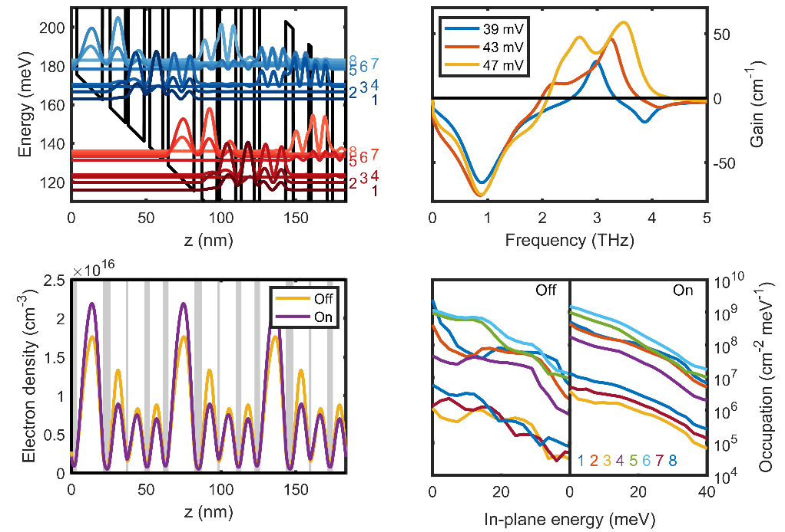
Figure 1: This is a caption for a figure.
References
[1] C. Weber, A. Wacker, and A. Knorr, “Density-matrix theory of the optical dynamics and transport in quantum cascade structures: The role of coherence,” Physical Review B, vol. 79, 165322 (2009).

